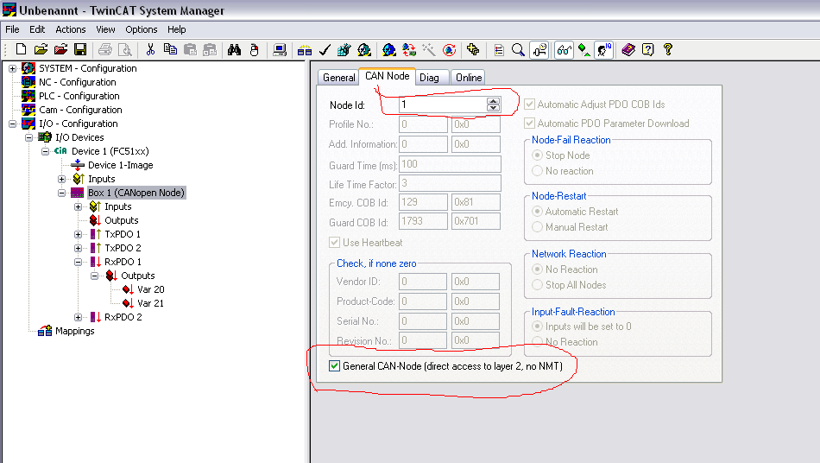

Please add a Canopen Node in systemmanager

- aktiveren General Can-Node (direkt access to layer 2, No NMT)
- choice a randrom Node Id ( it is a virtulle slave just for sending CAN commando)
- add two variable unter RXPDO1

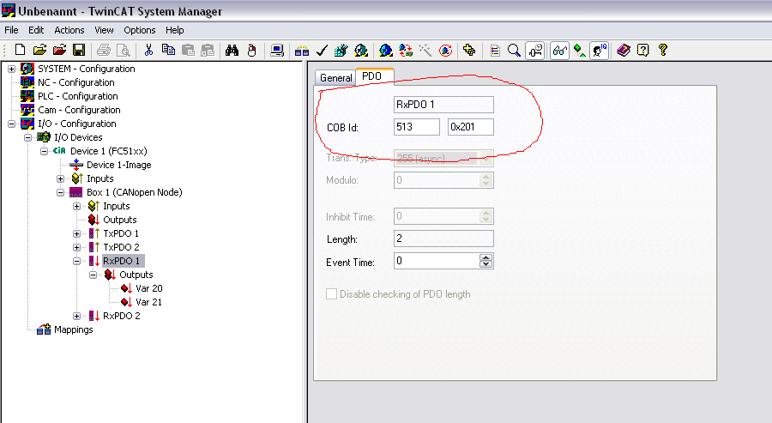

- change COB ID to 000 ( if you want to send NMT Message)
- links the variabe of RXPDO with your PLC Program.
- Rum PLC Porgram, ( if Variable20 =0x81, Variabe21=07, it means Node 7 will be reset)

