TwinCAT 3 NC PTP螺距补偿功能的使用方法
---史晓云

螺距补偿功能介绍
螺距补偿功能的原理是通过激光干涉仪测量机床各坐标轴的螺距误差，并将误差值存储在TwinCAT PLC中。当机床运行时，数控系统根据存储的误差值对运动指令进行修正，从而提高定位精度。
测试方法通常包括使用激光干涉仪或光栅尺等精密测量设备，测量机床全行程的误差值，并将这些值输入到PLC功能块的补偿参数中。其优势在于能够显著提高机床的定位精度和加工精度，并能够实时实现精度调整，尤其适用于高精度加工场景。

1、螺距补偿功能开关
轴参数OtherSeting开启PositionCorrection功能
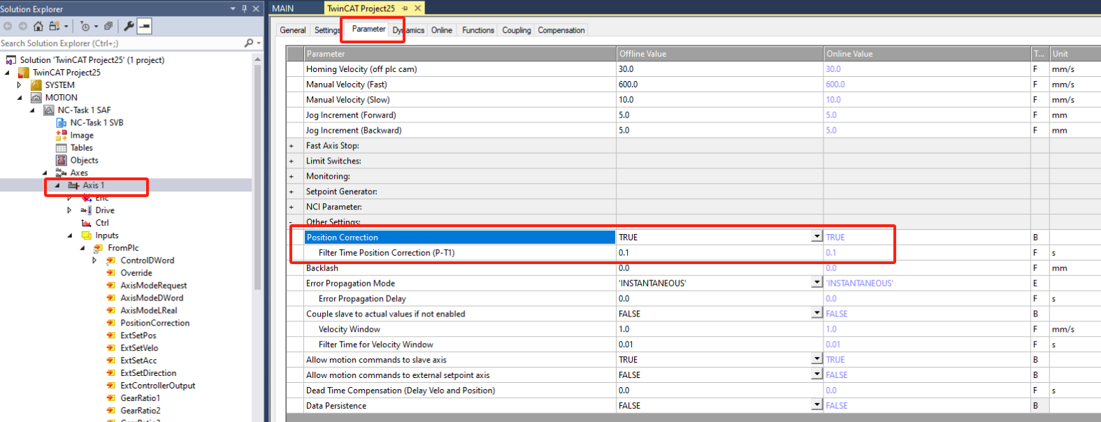

2、调用螺距补偿功能块
MC_TableBasedPositionCompensation功能块用于实现螺距补偿功能
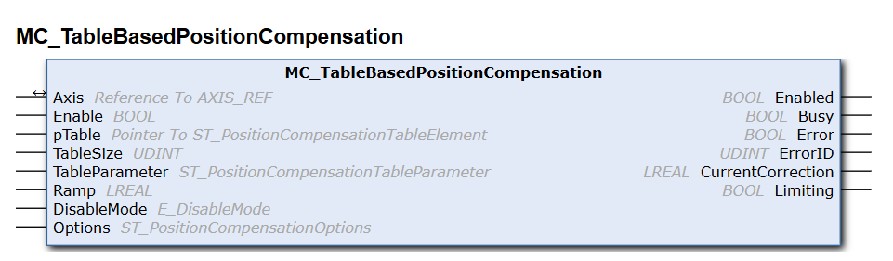

Name | Type | Description
Enable | BOOL | The command is executed as long as Enable is active.
pTable | POINTER To ST_PositionCompensationTableElement | Pointer to the compensation table, which is an array of the type St_PositionCompensationTableElement.
TableSize | UDINT | Size of the compensation table
TableParameter | ST_PositionCompensationTableParameter | Data structure with additional parameters for the compensation table.
Ramp | LREAL | Velocity limit for the entered compensation (constant velocity and linear position as subprofiles for table compensation [mm/s]).
DisableMode | E_DisableMode | Disable mode:
 |  | DisableModeHold = last correction is retained
 |  | DisableModeReset = last correction is set to 0
Options | ST_PositionCompensationOptions | Optional parameters (not implemented)

2.1功能块输入值
VAR_INPUT
Enable : BOOL;
pTable : POINTER To ST_PositionCompensationTableElement;
TableSize : UDINT;
TableParameter : ST_PositionCompensationTableParameter;
Ramp : LREAL;
DisableMode : E_DisableMode;
Options : ST_PositionCompensationOptions;
END_VAR

2.2 Inputs/outputs
VAR_IN_OUT
Axis : AXIS_REF;
END_VAR
Name | Type | Description
Axis | AXIS_REF | Axis data structure that unambiguously addresses an axis in the system. Among other parameters it contains the current axis status, including position, velocity or error state.

2.3 Outputs
VAR_OUTPUT
Enabled : BOOL;
Busy : BOOL;
Error : BOOL;
ErrorID : UDINT;
CurrentCorrection : LREAL;
Limiting : BOOL;
END_VAR
Name | Type | Description
Enabled | BOOL | This output becomes TRUE when the table compensation was enabled without errors.
Busy | BOOL | This output becomes TRUE when the command is started with Enable and remains so as long as the function block executes the command.
Error | BOOL | This output becomes TRUE if an error has occurred during command execution.
ErrorID | UDINT | Contains the command-specific error code of the last executed command. Details of the error code can be found in the ADS error documentation or in the NC error documentation (error codes 0x4nnn and 0x8nnn).
CurrentCorrection | LREAL | Current compensation value, in the unit of the axis.
Limiting | BOOL | This output is TRUE if the correction value associated with the position has not yet been fully applied.

3、调用螺距补偿程序

3.1配置补偿属性参数
ST_PositionCompensationTableParameter用于设定螺距补偿参数，包括最小位置及最大位置、补偿数量、补偿方向以及补偿类型等；
例如：stParameter : ST_PositionCompensationTableParameter
:= (MinPosition := -10.0, MaxPosition := 10.0,
NoOfTableElements := 21, Direction := WorkDirectionBoth);
TYPE ST_PositionCompensationTableParameter :
STRUCT
MinPosition : LREAL;
MaxPosition : LREAL;
NoOfTableElements : UDINT;
Direction : E_WorkDirection := WorkDirectionBoth;
Modulo : BOOL;
END_STRUCT
END_TYPE
Name | Type | Default | Description
MinPosition | LREAL |  | Start position for position compensation
MaxPosition | LREAL |  | End position for position compensation
NoOfTableElements | UDINT |  | Number of table entries
Direction | E_WorkDirection | WorkDirectionBoth | The position compensation is performed only in the selected direction.
Modulo | BOOL |  | FALSE: linear axis
 |  |  | TRUE: modulo axis with cyclic period

3.2配置补偿数据
ST_PositionCompensationTableElement包含位置及补偿量，通过数组进行个点位置补偿
例如：stPosTable : ARRAY[0..20] OF ST_PositionCompensationTableElement : ARRAY[0..20] OF ST_PositionCompensationTableElement
:= [ ( Position := -10.0, Compensation := 1.0 ),
( Position := -9.0, Compensation := 0.9 ),
( Position := -8.0, Compensation := 0.8 ),
( Position := -7.0, Compensation := 0.7 ),
( Position := -6.0, Compensation := 0.6 ),
TYPE ST_PositionCompensationTableElement :
STRUCT
Position : LREAL;
Compensation : LREAL;
END_STRUCT
END_TYPE
Name | Type | Description
Position | LREAL | Uncorrected position value (e.g. SetPos)
Compensation | LREAL | Additive compensation value

3.3关闭补偿时，补偿值生的设置
E_DisableMode:
DisableMode | E_DisableMode | Disable mode:  DisableModeHold = last correction is retained  DisableModeReset = last correction is set to 0

4、程序调用
见示例例程《TC3-NC PTP-TableComp》
PROGRAM PRG_TableComp
VAR
fbTableComp : MC_TableBasedPositionCompensation;
Axis1 : AXIS_REF;
bTableCompEnable : BOOL
Ramp : LREAL:=200;
DisableMode : E_DisableMode;
Options : ST_PositionCompensationOptions;
stTablePara : ST_PositionCompensationTableParameter
:= (MinPosition := -10.0, MaxPosition := 10,
NoOfTableElements := 21, Direction := WorkDirectionBoth);
stTableValue : ARRAY[1..21] OF ST_PositionCompensationTableElement
:= [
( Position := -10.0, Compensation := -1.0 ), ( Position := -9.0, Compensation := -0.9 ),
( Position := -8.0, Compensation := -0.8 ), ( Position := -7.0, Compensation := -0.7 ),
( Position := -6.0, Compensation := -0.6 ), ( Position := -5.0, Compensation := -0.5 ),
( Position := -4.0, Compensation := -0.4 ), ( Position := -3.0, Compensation := -0.3 ),
( Position := -2.0, Compensation := -0.2 ), ( Position := -1.0, Compensation := -0.1 ),
( Position := 0.0, Compensation := 0.0 ), ( Position := 1.0, Compensation := 0.1 ),
( Position := 2.0, Compensation := 0.2 ), ( Position := 3.0, Compensation := 0.3 ),
( Position := 4.0, Compensation := 0.4 ), ( Position := 5.0, Compensation := 0.5 ),
( Position := 6.0, Compensation := 0.4 ), ( Position := 7.0, Compensation := 0.3 ),
( Position := 8.0, Compensation := 0.2 ), ( Position := 9.0, Compensation := 0.1 ),
( Position := 10.0, Compensation := 0.0 )
];
END_VAR
fbTableComp(
Axis := Axis1,
Enable := bTableCompEnable,
pTable := ADR(stTableValue),
TableSize := SIZEOF(stTableValue),
TableParameter := stTablePara,
Ramp := Ramp,
DisableMode := DisableMode,
Options := Options,
Enabled=> ,
Busy=> ,
Error=> ,
ErrorID=> ,
CurrentCorrection=> ,
Limiting=> );

5、螺距补偿验证
通过当前位置、纠偏位置等可以看对应的偏差值，另外也可以通过配置文件读到当前的偏差值。

5.1通过配置文件设置纠偏量
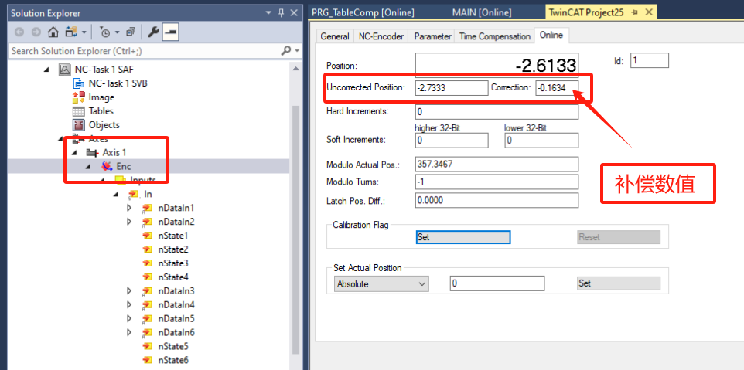

5.2通过Scop view抓图显示补偿数值
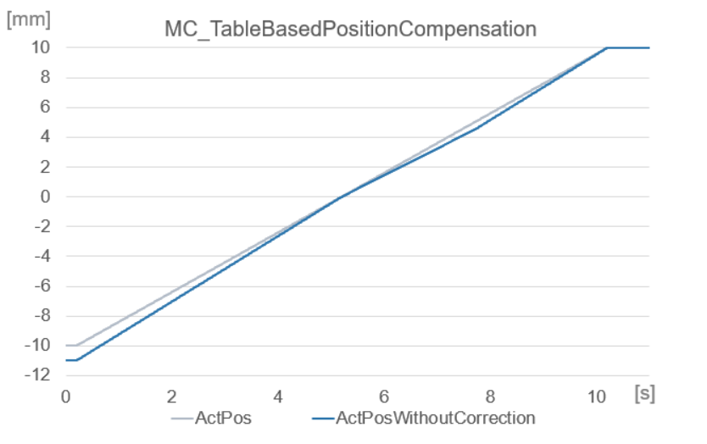

6、螺距补偿问答
A、螺距补偿是否可以实时激活使用，是可以随时修改并随时关闭的；
B、螺距补偿值是绝对值的，补偿参数需要不断累加，也就是新的补偿值需要叠加现有数值进行补偿；
C、螺距补偿单位是mm
D、螺距补偿对于速度限制或者下发周期可以通过RAMP参数进行限定下发速度

